**Set up the Virtual Machine**

**(*adapted from Oksana Lukjancenko, Technical University of Denmark*)**

For this course you will use a virtual computer that works almost like a normal computer. First you need to install the ”Virtual Box” program that will allow you to run this virtual computer. You will then import a setup to the virtual computer, a so-called virtual hard-disk file (*Workshop.vdi*), which holds all the tools required for the final assessment exercises II-IV.

1. **Install Virtual Box and start up the Virtual Machine (VM)**

• Download the program virtualbox from this link: <http://www.virtualbox.org/wiki/Downloads>

(version: select the one that fits your computer)

• Install the program VirtualBox following the installation steps

• Start the VirtualBox

• Click new (the blue icon on the left of the tool bar)

• Type *MG_workshop* in the VM name dialog box (Figure 1(a)).

• Select *Linux* (Operating system) and *Ubuntu* (Version) in the Name and operating system dialog

(Figure 1(a)).

• Leave the Memory size form as default (Figure 1(b)).

• Select *Use an existing virtual hard disk file* in the virtual hard disk settings (Figure 1(c))

• Select the *Workshop.vdi* file in the virtual hard disk settings (Figure 1(c))

• Click *Create* in the Hard disk dialog (Figure 1(c)).

• Click the *Settings* icon for the computer. Under the *General* tab, select *Advanced*. In the menu

*Shared Clipboard* select *Bidirectional* and click OK (Figure 1(d)).

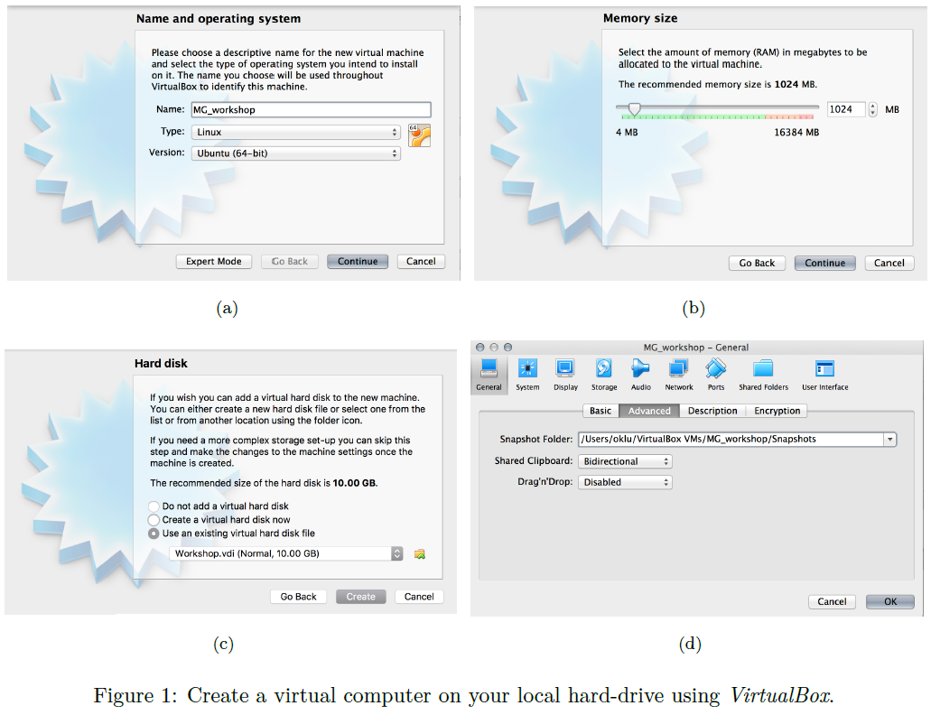

1. **Set up a shared folder**

The virtual computer runs as an independent computer on your hardware, which means that it does not have access to the data which is on your local computer. However, it is possible to set up folders in your local computer that the virtual computer can access, these are called *shared* folders. Keeping the data you need in a shared folder, takes up less of the virtual computer space, making it possible to run a small virtual computer (4GB) while still having a large dataset.

Now, you will set up a shared folder in a two step process.

1. First, the folder is set up in the Virtualbox program:

• Create a folder called *“Workshop”* in your local computer. Do not place it directly in the Desktop or

Documents, but inside of another folder.

• In the Virtualbox window, click the *Settings* tab for the *MG_workshop* virtual computer (Figure 2(a)).

• In the new window, click the *Shared* folders (Figure 2(b)).

• Click the little folder icon with a green plus on it (Figure 2(b)).

• Select the *“Workshop”* folder on your local computer (Figure 2(c)).

• The Folder Name is automatically set to be the same as the folder you selected (Figure 2(c)). Leave it as *“Workshop”.*

• Make the shared folder *Auto-mount* and *Make Permanent* if this option exists, then click OK (Figure 2(c)).

• The folder is now listed under the Machine folders; click OK and Start the Virtual computer by clicking the green arrow *Start*.

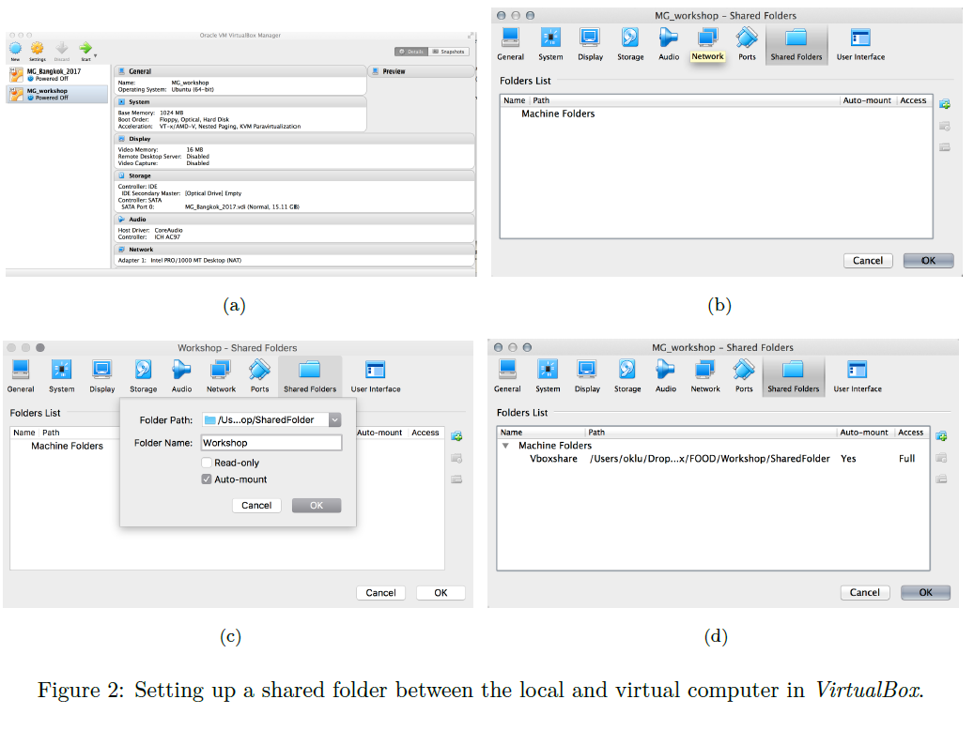

1. Next, the folder is set up in the virtual computer. Note, in the lower right corner of the virtual computer there is now a little blue folder icon. If no shared folder has been specified, this icon is grey.

• Open the Terminal Emulator from mouse right-click menu on the desktop *(“Open terminal”)* or by clicking on the terminal icon on the vertical menu on the left.

• To link a folder to the virtual computer, the shared folder needs to be connected to an existing virtual folder. For this, you need to create a folder on the virtual computer, which will be linked (mounted) to your local computer. To create the folder in the virtual computer, type the following command into the Terminal Emulator:

mkdir /home/user/Vboxshare

A folder called Vboxshare has now been created in the home directory of the user, in the virtual machine.

**N.B. If a folder with this name already exists in that location, ignore the step above.**

**N.B. If you experience difficulties in creating the shared folder due to lack of space, this might be due to the fact that the virtual machine already includes fastq sample files, which take up a lot of space.**

**If you run into this issue, you can delete the sample files distributed on the .vdi with the command:**

**rm /home/user/WorkshopData/*gz** .**Afterwards, repeat the step described above.**

• Once the Vboxshare solder is created, in the terminal window type the following command:

sudo mount -t vboxsf -o uid=1000,gid=1000 Workshop /home/user/Vboxshare

Here *“Workshop”* should be the name of the folder on your local computer, while *“Vboxshare”* should be the name of the folder you just created on the virtual computer. Save the file.

**N.B. You might have to repeat this step, until the folder is really shared between both computers. To test it, place a document in the folder “Workshop” in your local computer, and see if it appears in the “Vboxshare” folder in the virtual machine.**

• Whenever the terminal asks you for a user password, **type 1234.**

• Reboot the virtual computer.